**BLOODBANK MANAGEMENT SYSTEM**

**Project Report**

*Submitted in fulfilment for the J-Component of ITE1008 – Open Source*

*Programming*

**CAL Course**

***In***

**B.Tech. (Information Technology)**

*By*

**B K ANIRUDH (19BIT0348)**

**LANKA JASWANTH (19BIT0061)**

**MANAM LAXMI NIVAS (19BIT0189)**

**B MANISH RAO(19BIT0333)**

*Under the guidance of*

**Prof. Jayakumar Sadhasivam**

**SITE**





**School of Information Technology and Engineering**

Fall Semester 2020-2021

**TABLE OF CONTENTS**

|  |  |  |
| --- | --- | --- |
| **CHAPTER NO.** | **TITLE** | **PAGE NO.** |
|  | Abstract | **3** |
|  | Introduction | **4** |
|  | Problem Statement | **5** |
|  | Process Flow Diagram | **8** |
|  | Modules | **9** |
|  | ER Diagram | **10** |
|  | Database Design | **11** |
|  | Conclusion | **12** |
|  | References | **12** |
|  | Snapshots | **13-20** |
|  | Source Code | **21-22** |

**ABSTRACT :**

-- The main aim to help needy people in case of emergencies.

-- Blood donor play very important role in the healthcare of patients in our community.

-- Most population are eligible to donate blood yet very few actually do.

-- Every year, a huge number of individuals depend on accepting and giving blood

to remain alive.

-- So, we have created a platform for blood donors where they can fill their

details and our team

will reach their locations for safe blood transfusion.

-- Blood bank may be one of the absolute best instances of unselfishness in real life for

fulfilling the Need of blood to people.

# INTRODUCTION

->The project BLOODBANK SYSTEM is a project that is designed

for a blood bank to gather blood from various sources and

distribute it to the needy people who have high requirements for it.

->The software is designed to handle daily transactions of

blood bank and search the details when required.

->It also helps to register the details of donor, blood collection

details as well as blood issued reports.

->The software application is designed in such a manner that it

can the needs of all blood bank requirements in the course of

future.

# GOALS AND OBJECTIVES

The goals and objectives of the Blood Bank Management System are as

follows:

* To provide a means for the blood bank to publicize and advertise blood donation programs.
* To allow the probable recipients to make search and match the volunteer donors, and make request for the blood.
* To provide an efficient donor and blood stock management functions to the blood bank by recording the donor and blood details.
* To improve the efficiency of blood stock management by alerting the blood bank staffs when the blood quantity is below it par level or when the blood stock has expired.
* To provide synchronized and centralized donor and blood stock database.
* To provide immediate storage and retrieval of data and information.

# EXISTING SYSTEM

 Time consuming

 Leads to error prone results  Consumes lot of manpower  Lacking of donor information

 Uncertainty of Donor availability  Retrieval of data takes lot of time  Percentage of accuracy is less

# PROPOSED SYSTEM

* + Access from anywhere of world
  + Access at any time
  + Quick Search
  + Better Communication
  + Optimize to volunteer
  + Time Optimize
  + Cost Optimize

# ADVANTAGE

* Access from anywhere of world
* Access at any time
* Quick Search
* Better Communication
* Optimize to volunteer
* Time Optimize
* Cost Optimize

# DISADVANTAGE

* At present it is available for some limited zone.
* Problem to calculate number of donor available in list.
* Difficulty in identifying blood donor’s expiry date.
* In future we must overcome this drawback by using modern technologies

**PROCESS FLOW DIAGRAM**

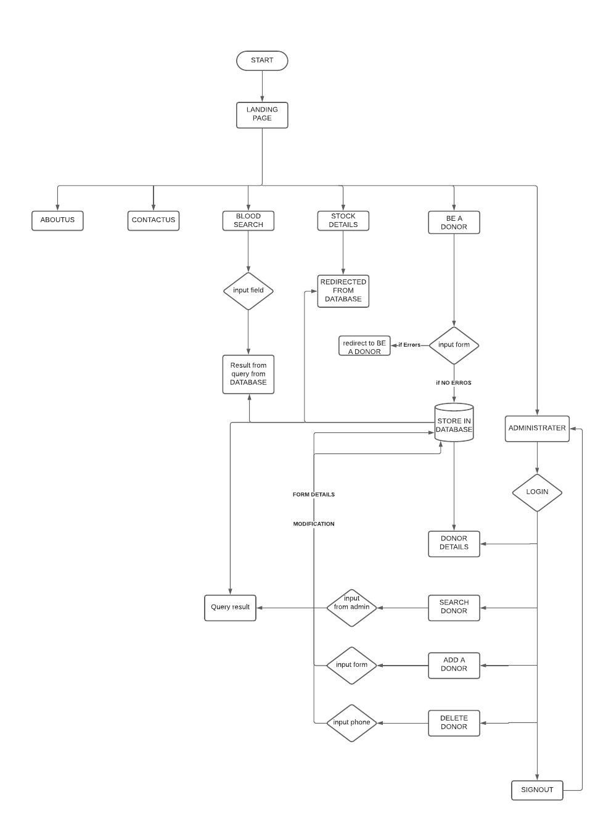

**MODULES**

* Blood Bank (HOME)
* About us
* Contact us
* Blood Search
* Stock Details
* Be a donor
* Administrator login

**TECHNOLOGIES:**

* HTML
* CSS
* BOOTSTRAP
* JAVASCRIPT
* JQUERY
* ANGULARJS
* ICONS AND FONTS (font awesome.com)
* PHP AND MySQL

**TOOLS:**

* VS code
* XAMPP
* BROWSERSYNC

#### E.R DIAGRAM

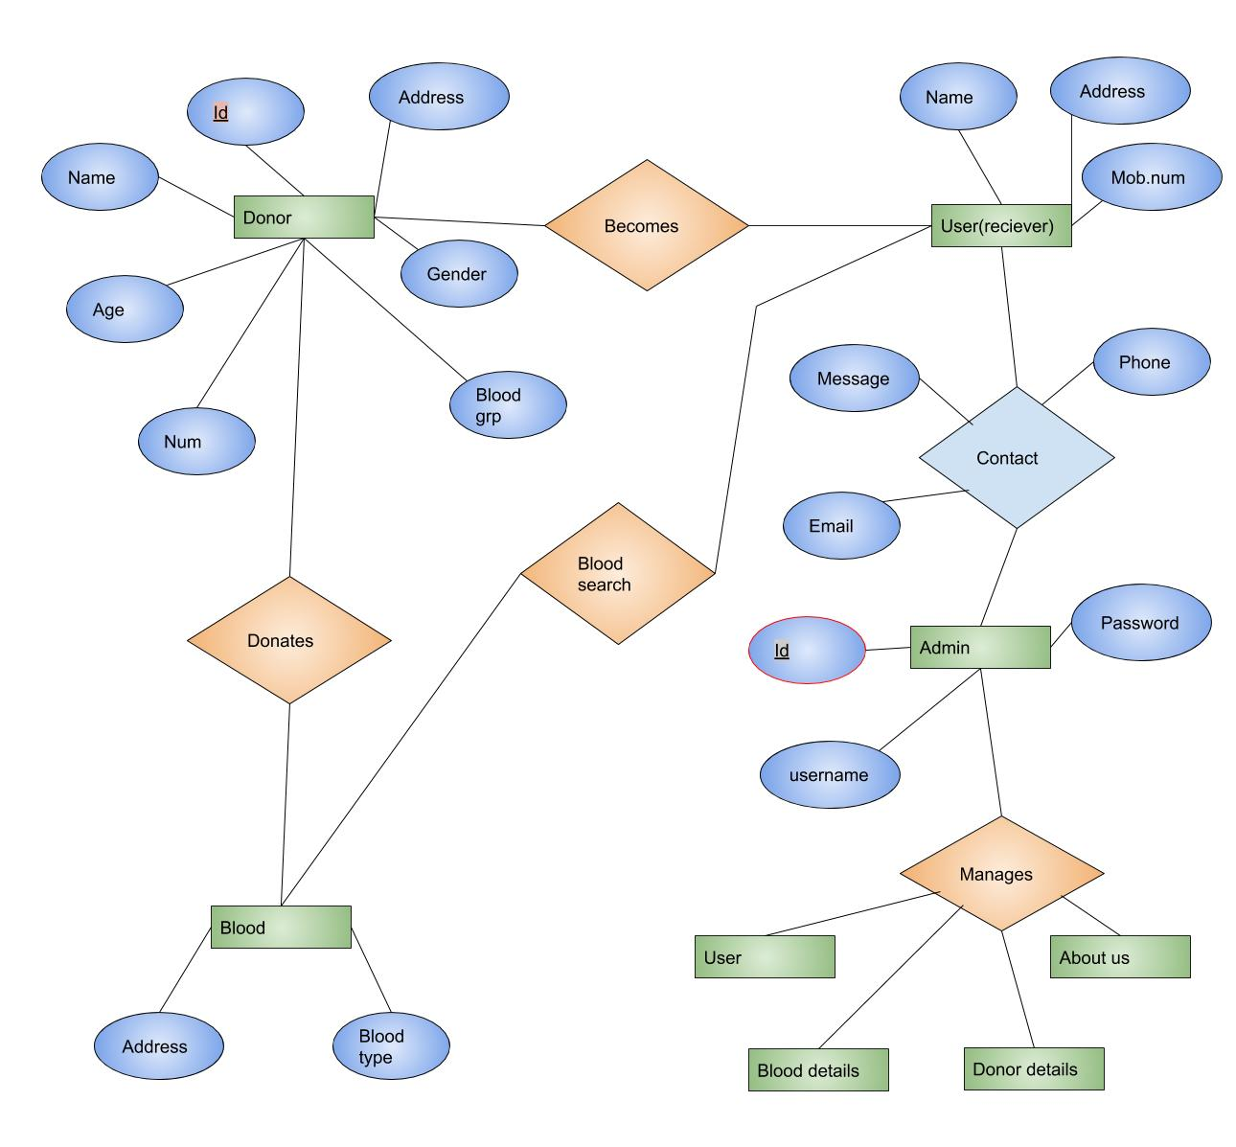

**E.R Diagram of project.**

Donor entity have name, age, blood group, mobile no, address, gender and id attributes which have relation with donates blood and blood type where blood entity has relation with search blood which has relation with user/receiver and user have relation with contact entity which can be managed by the admin panel for that you required ‘username’ and ‘password’ which manages ‘User’, ‘Blood details’, ‘Donor Details’ and ‘About us’ page

**DATABASE DESIGN:**

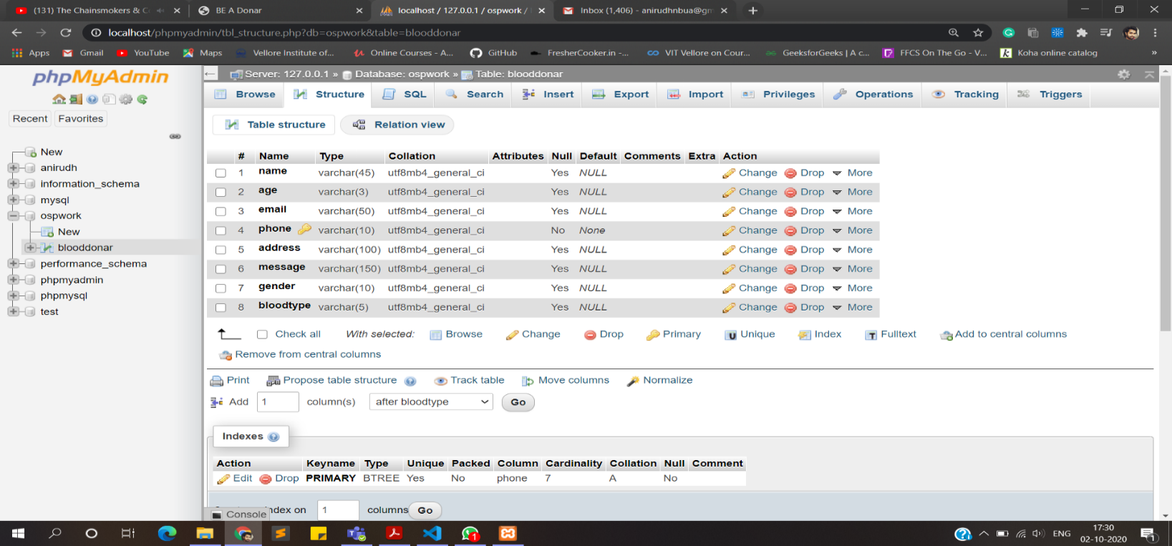**i)table**

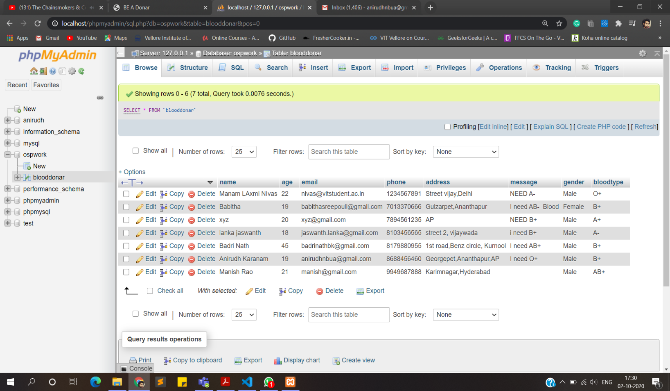**ii)data inserted thorough forms**

**CONCLUSION**

The goals and objectives of the Blood Bank Management System are as

follows:

* To provide a means for the blood bank to publicize and advertise blood donation programs.
* To allow the probable recipients to make search and match the volunteer donors, and make request for the blood.
* To provide an efficient donor and blood stock management functions to the blood bank by recording the donor and blood details.
* To improve the efficiency of blood stock management by alerting the blood bank staffs when the blood quantity is below it par level or when the blood stock has expired.
* To provide synchronized and centralized donor and blood stock database.
* To provide immediate storage and retrieval of data and information.

**REFERENCES**

[**https://www.w3schools.com/**](https://www.w3schools.com/)

[**https://stackoverflow.com/**](https://stackoverflow.com/)

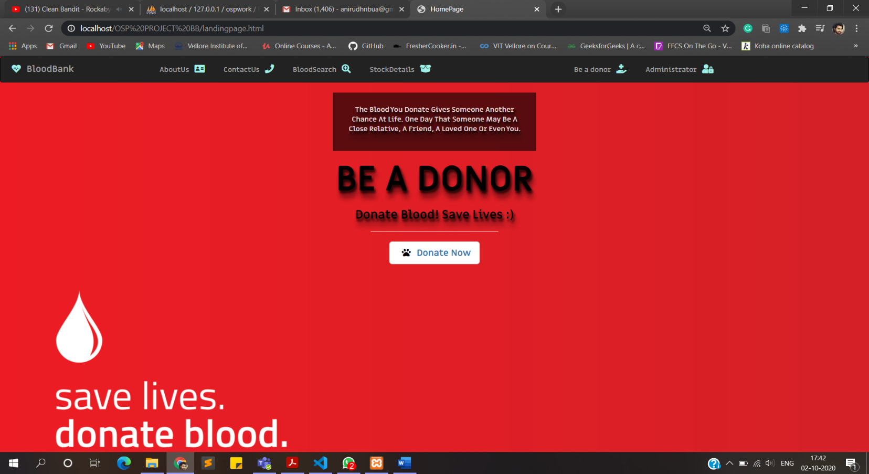**SNAPSHOTS LANDING PAGE**

**ABOUT US:**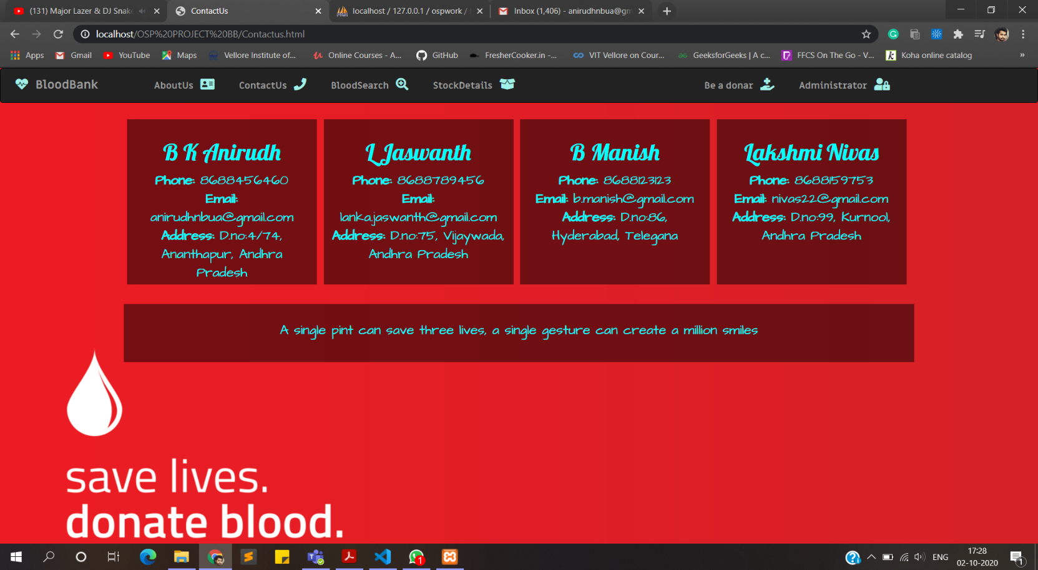

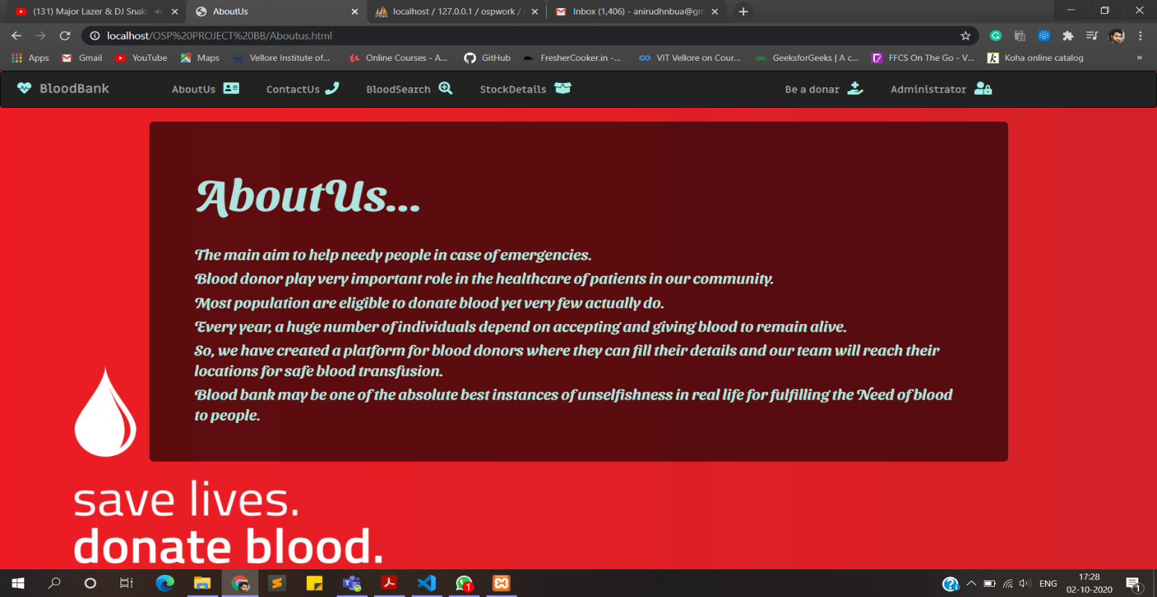**CONTACT US:**

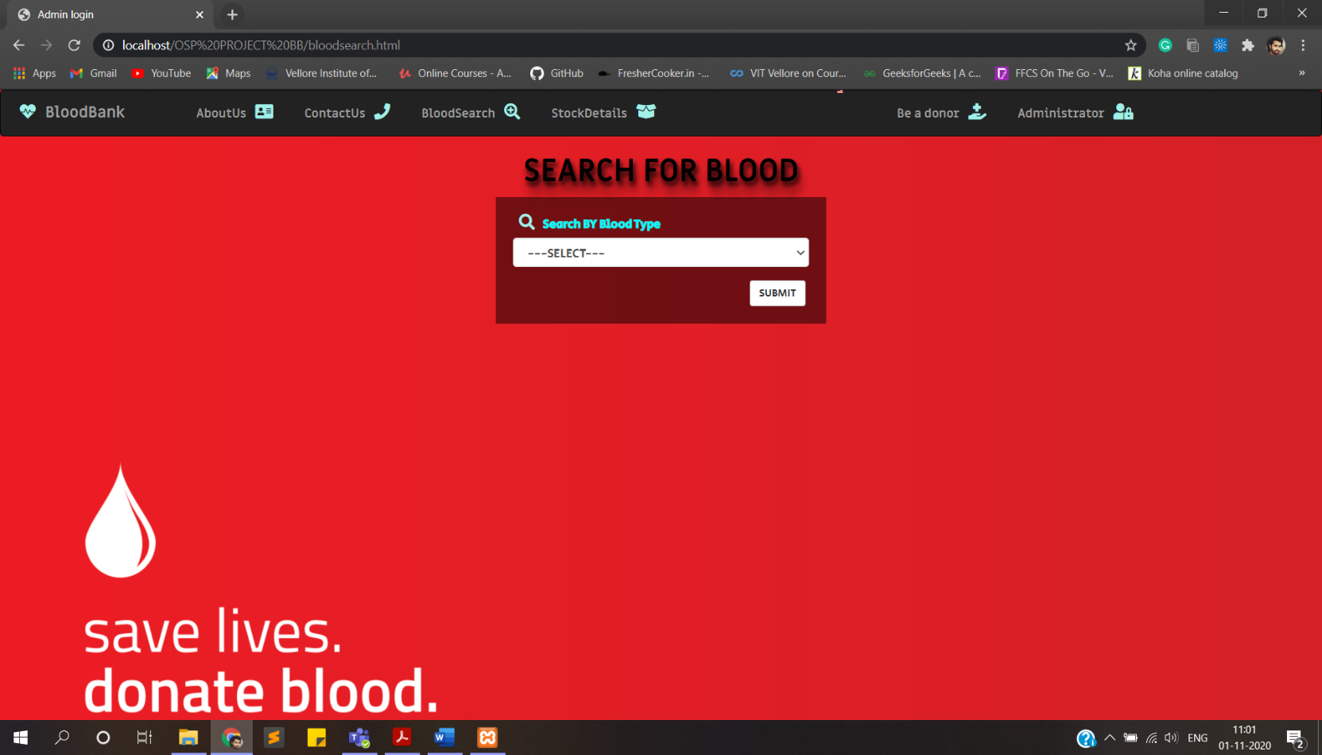**BLOOD SEARCH:**

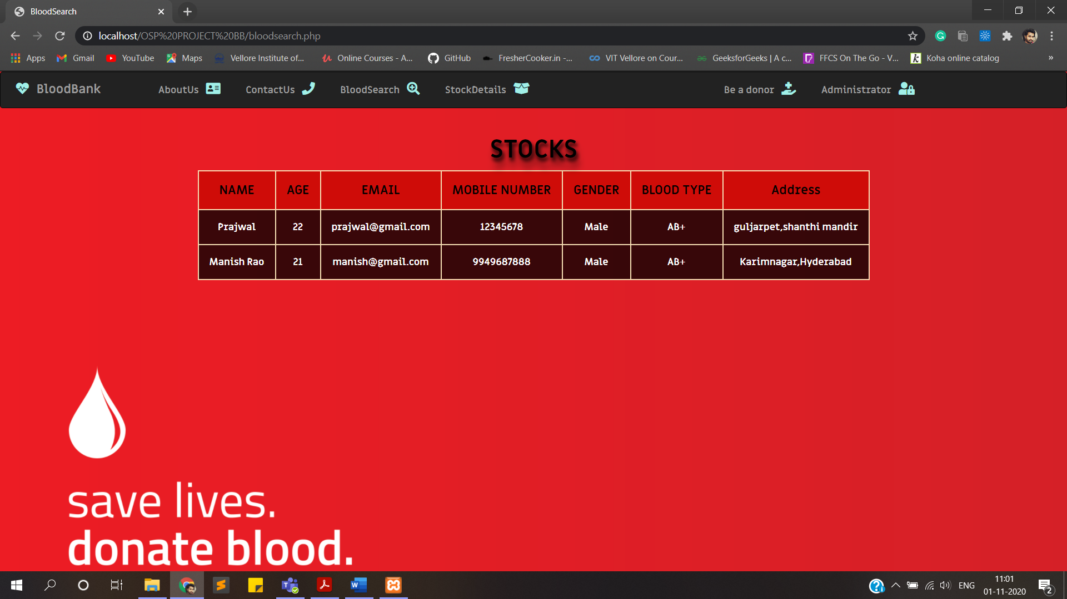**BLOOD SEARCH RESULT:**

**STOCK DETAILS:**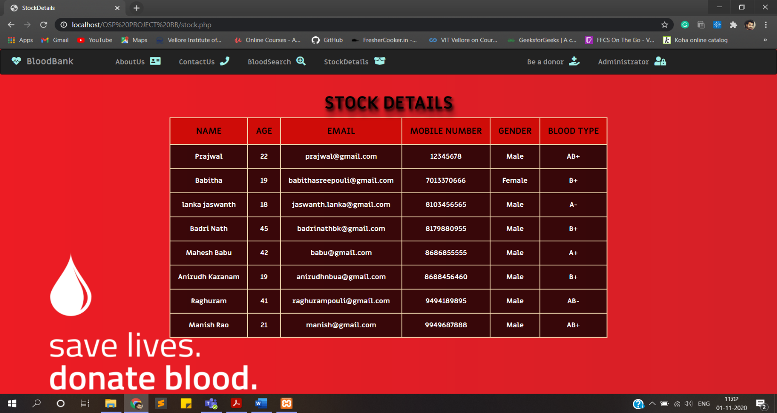

**BE A DONOR (REGISTRATION FORM)**

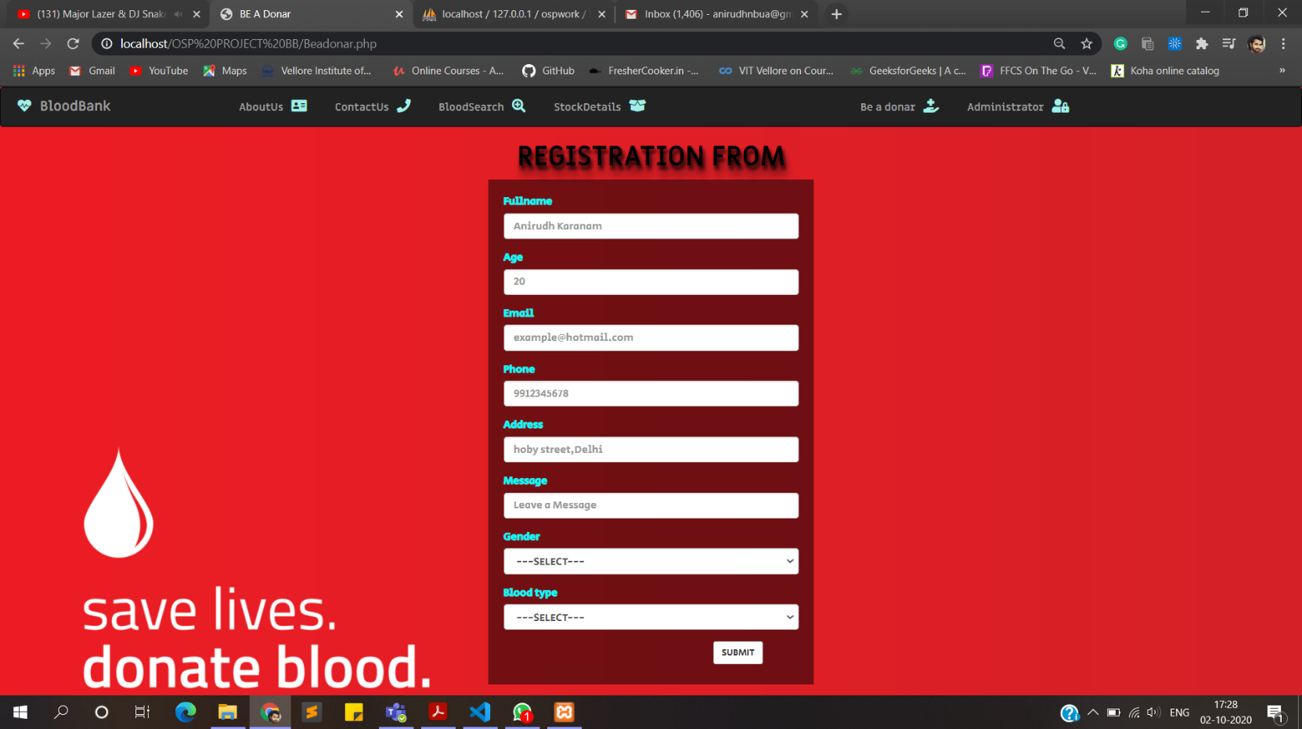**i)form**

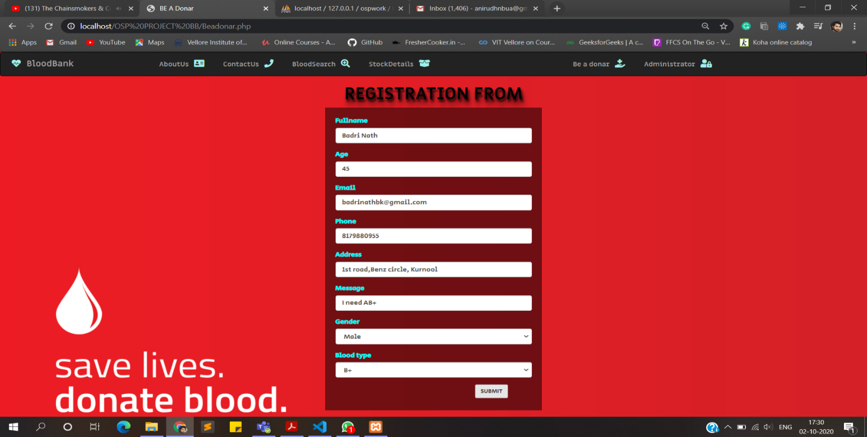**ii)data entry**

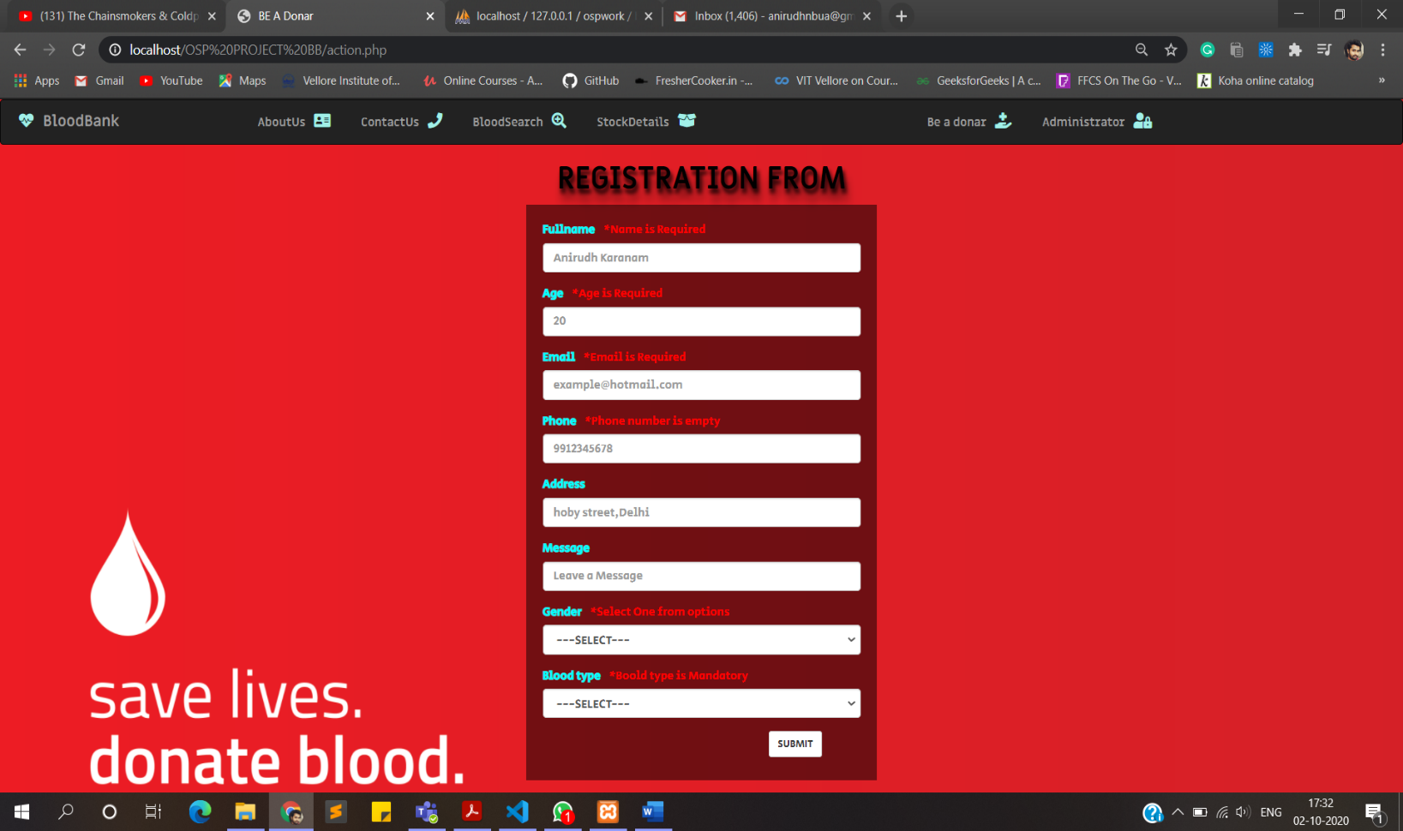**iii)validation**

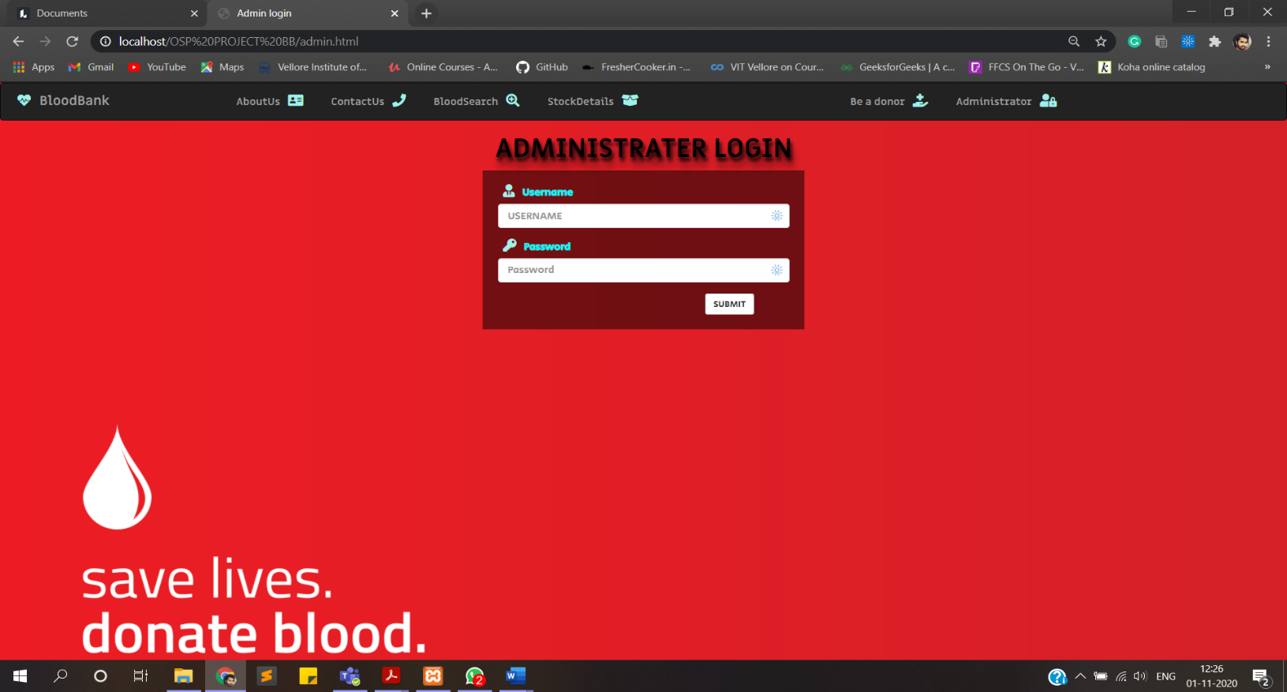**ADMINISTRATOR LOGIN**

**ADMINISTRATION PANAL (after admin login)**

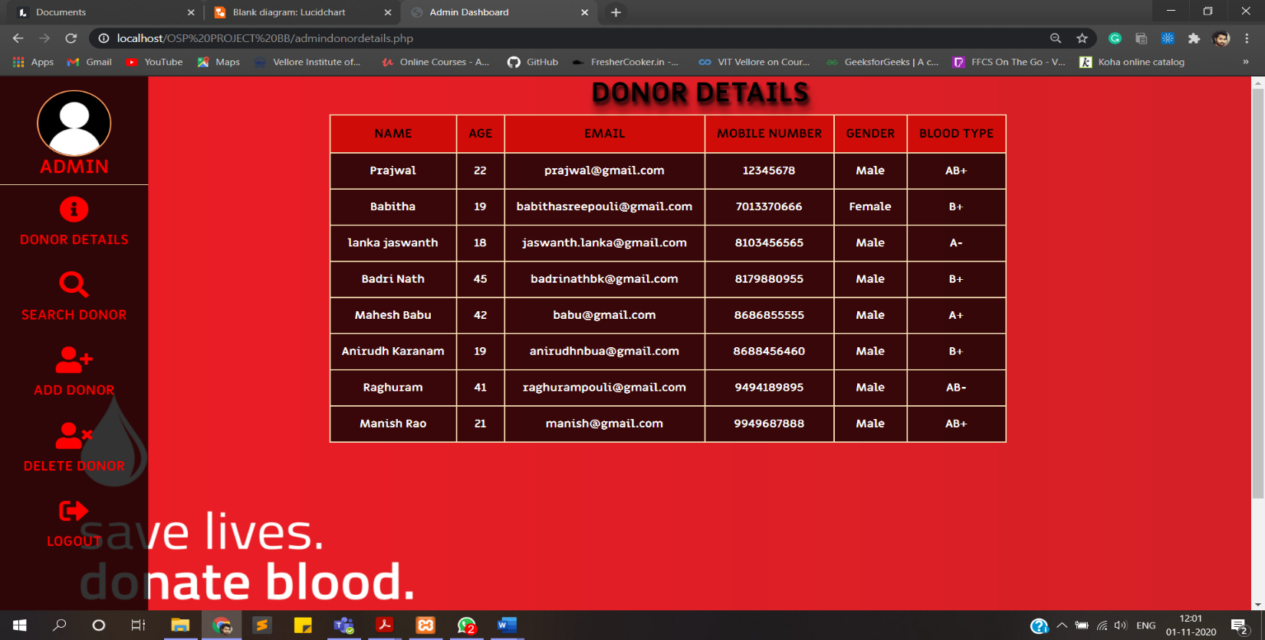**DONOR DETAILS**

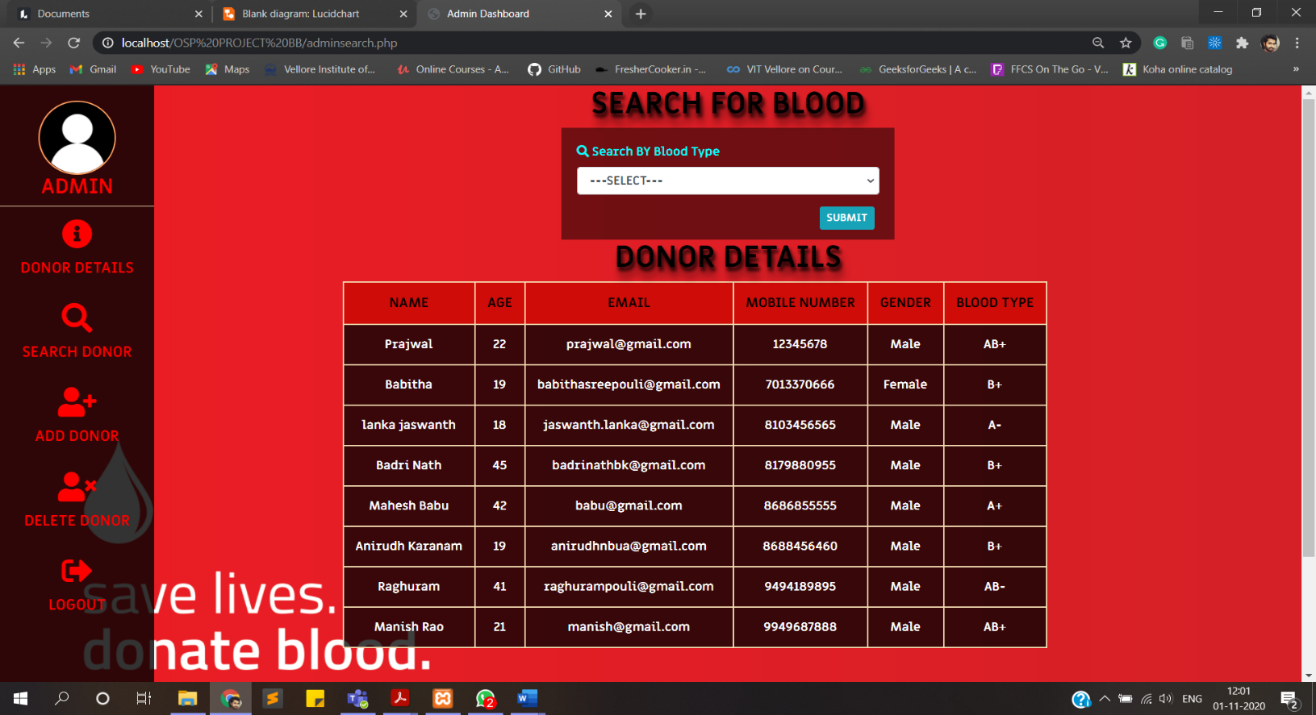**SEARCH DONOR**

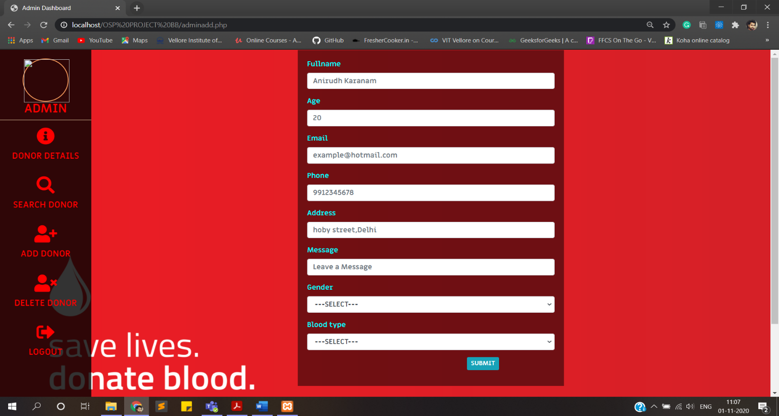**ADD DONOR**

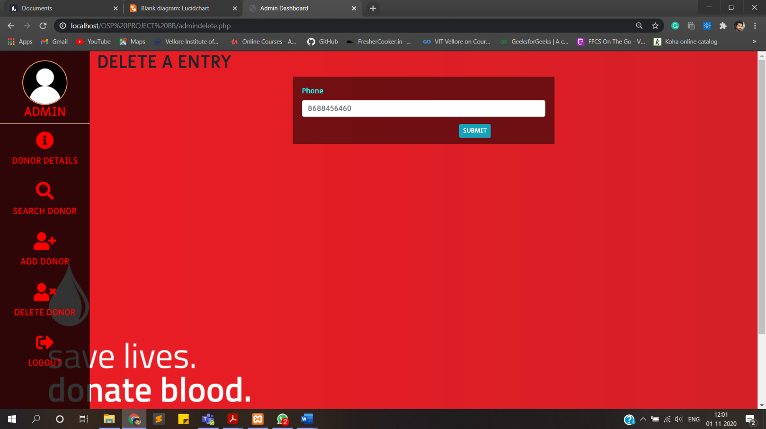**DELETE DONOR**

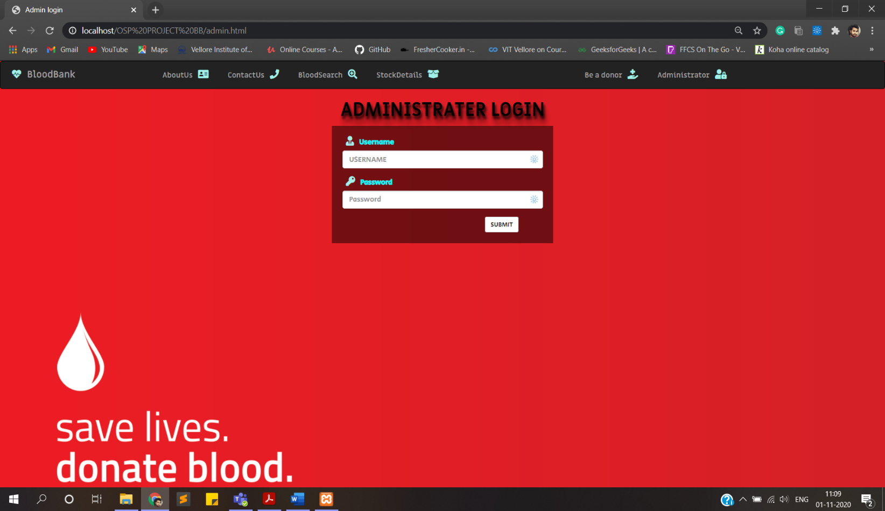**ON LOGOUT**

**SOURCE CODE:**

<!DOCTYPE *html*>

<html>

    <head>

        <title>HomePage</title>

        <link *rel*="stylesheet" *href*="https://maxcdn.bootstrapcdn.com/bootstrap/3.3.7/css/bootstrap.min.css" *integrity*="sha384-BVYiiSIFeK1dGmJRAkycuHAHRg32OmUcww7on3RYdg4Va+PmSTsz/K68vbdEjh4u" *crossorigin*="anonymous">

        <link *rel*="stylesheet" *href*="https://use.fontawesome.com/releases/v5.14.0/css/all.css" *integrity*="sha384-HzLeBuhoNPvSl5KYnjx0BT+WB0QEEqLprO+NBkkk5gbc67FTaL7XIGa2w1L0Xbgc" *crossorigin*="anonymous">

        <script *src*="https://code.jquery.com/jquery-3.5.1.min.js" *integrity*="sha256-9/aliU8dGd2tb6OSsuzixeV4y/faTqgFtohetphbbj0=" *crossorigin*="anonymous"></script>

        <link *rel*="stylesheet" *href*="landingpage.css">

        <link *href*="https://fonts.googleapis.com/css2?family=Miriam+Libre:wght@700&display=swap" *rel*="stylesheet">

    </head>

    <body>

        <nav *class*="navbar navbar-inverse">

            <div *class*="container-fluid">

              <div *class*="navbar-header">

                <button *type*="button" *class*="navbar-toggle collapsed" *data-toggle*="collapse" *data-target*="#bs-example-navbar-collapse-1" *aria-expanded*="false">

                  <span *class*="sr-only">Toggle navigation</span>

                  <span *class*="icon-bar"></span>

                  <span *class*="icon-bar"></span>

                  <span *class*="icon-bar"></span>

                </button>

                <a *class*="navbar-brand" *href*="landingpage.html"><i *class*="fas fa-heartbeat"></i> BloodBank</a>

              </div>

            <div *class*="container">

              <div *class*="collapse navbar-collapse" *id*="bs-example-navbar-collapse-1">

                <ul *class*="nav navbar-nav">

                    <li><a *href*="Aboutus.html">AboutUs <i *class*="fas fa-address-card"></i></a></li>

                    <li><a *href*="Contactus.html">ContactUs <i *class*="fas fa-phone"></i></a></li>

                    <li><a *href*="bloodsearch.html">BloodSearch <i *class*="fas fa-search-plus"></i></a></li>

                    <li><a *href*="stock.php">StockDetails <i *class*="fas fa-box-open"></i></a></li>

                </ul>

                <ul *class*="nav navbar-nav navbar-right">

                  <li><a *href*="Beadonar.php">Be a donor  <i *class*="fas fa-hand-holding-medical"></i></a></li>

                  <li><a *href*="admin.html">Administrator   <i *class*="fas fa-user-lock"></i></a></li>

                </ul>

              </div>

            </div>

            </div>

          </nav>

        <div *class*="container">

            <div *class*="col-lg-12">

                <div *id*="content">

                    <div *id*="quote">

                        <p>The Blood You Donate Gives Someone Another Chance At Life. One Day That Someone May Be A Close Relative, A Friend, A Loved One Or Even You.</p>

                    </div>

                    <h1>BE A DONOR</h1>

                    <h3>Donate Blood! Save Lives :)</h3>

                    <hr>

                    <button *class*="btn btn-default btn-lg"><a *href*="Beadonar.php"><i *class*="fas fa-paw spl"></i>    Donate Now</a></button>

                </div>

            </div>

        </div>

    </body>

</html>